Phase 4: Implement Client Script & UI Policy (Incident) in ServiceNow
Project Planning Phase
1. Introduction
The Project Planning Phase is an important stage in software development. It defines how the project will be carried out, what activities need to be completed, what resources are required, and how much time should be allocated to each task.
In this project, the planning phase focuses on implementing UI Policies and Client Scripts in ServiceNow to improve the accuracy and consistency of Incident records. The plan includes preparing the ServiceNow environment, configuring the UI Policy, developing Client Scripts, testing the functionality, and documenting the results.
The project is divided into manageable activities so that each component can be implemented and verified in an organized manner.
2. Objectives of Project Planning
The main objectives of this phase are:
- To organize the project activities in a clear sequence.
- To identify the tools, resources, and access required.
- To allocate time for configuration, scripting, and testing.
- To identify possible implementation risks and ways to handle them.
- To define the responsibilities and expected outputs of each activity.
- To ensure that the completed system meets the requirements identified during analysis.
3. Project Scope
The project focuses on client-side controls for the ServiceNow Incident table.
Included in the project
- Creating the High Impact Control UI Policy.
- Making Assignment Group mandatory when Impact is High.
- Making Urgency read-only when Impact is High.
- Automatically setting Urgency to High when Impact changes to High.
- Preventing submission when Assigned To is empty for a High Impact incident.
- Preventing direct State changes through list editing.
- Testing the configured behavior and documenting the results.
Outside the project scope
- Developing a new Incident Management application.
- Creating a separate database or external backend.
- Changing ServiceNow's core Incident Management architecture.
- Implementing server-side business rules or integrations not specified in the project.
4. Project Activities and Schedule
The project activities are arranged in a sequence, beginning with preparation and ending with testing and documentation. The following is a proposed schedule for a short-duration micro project.
Phase | Activity | Estimated duration
1 | Project preparation and requirement review | ½ day
2 | ServiceNow instance setup and access verification | ½ day
3 | Create High Impact Control UI Policy | ½ day
4 | Configure UI Policy Actions | ½ day
5 | Develop onChange Client Script | ½ day
6 | Develop onSubmit Client Script | ½ day
7 | Develop onCellEdit Client Script | ½ day
8 | Perform functional testing and corrections | 1 day
9 | Prepare screenshots and project documentation | ½ day
Total |  | 5 days
This is an estimated plan for organizing the work, not a recorded duration from the project document.
5. Work Breakdown Structure
The Work Breakdown Structure (WBS) divides the project into smaller tasks that are easier to complete and monitor.
- Project preparation
  - Review the problem statement and objective.
  - Identify the fields and business rules.
  - Confirm access to the ServiceNow instance.
- UI Policy configuration
  - Navigate to System UI → UI Policies.
  - Create the High Impact Control policy.
  - Set the condition to Impact is High.
  - Enable Reverse if false.
- UI Policy Actions
  - Make Assignment Group mandatory.
  - Make Urgency read-only.
  - Keep Urgency visible.
  - Verify that the actions reverse when Impact is no longer High.
- Client Script development
  - Create the onChange script for automatic Urgency updates.
  - Create the onSubmit script for Assigned To validation.
  - Create the onCellEdit script for State list-edit restriction.
- Testing and correction
  - Test the High Impact condition.
  - Test automatic Urgency updates.
  - Test submission with Assigned To empty and filled.
  - Test the reverse condition.
  - Test list editing and form-based State updates.
- Documentation and completion
  - Record the configuration details.
  - Capture screenshots of the completed tasks.
  - Document test results and the conclusion.
6. Resource Planning
Resource planning identifies the resources needed to complete the project.
6.1 Hardware resources
Resource | Purpose
Computer or laptop | Access ServiceNow and configure the project
Keyboard and mouse | Enter configuration details and scripts
Internet connection | Connect to the ServiceNow instance
6.2 Software resources
Software or platform | Purpose
ServiceNow instance | Main platform for development and testing
Web browser | Access the ServiceNow interface
Text editor (optional) | Draft and review Client Script code
Document editor | Prepare the project report
6.3 Human resources
The project can be completed by an individual student or developer with suitable ServiceNow access.
- Developer: Configures the UI Policy, creates Client Scripts, and corrects errors.
- Tester: Checks each requirement and records whether the expected behavior occurs.
- Project documenter: Prepares the report, screenshots, and testing records.
For an individual micro project, one person may perform all three responsibilities.
7. Task Dependency Planning
Some activities must be completed before others can begin.
Task | Depends on
Create UI Policy | Instance access and requirement review
Configure UI Policy Actions | UI Policy creation
Develop onChange script | Requirement review and Incident field knowledge
Develop onSubmit script | Requirement review and Incident field knowledge
Develop onCellEdit script | Requirement review and Incident list access
Test the complete configuration | Completion of configuration and scripts
Final documentation | Configuration and testing results
The UI Policy must be created before its related actions can be attached. Testing should take place after the configuration has been saved and activated.
8. Risk Management
Risk management identifies possible problems that may delay implementation or affect the expected results.
Possible risk | Effect | Planned solution
Missing administrative access | Unable to create policies or scripts | Verify access before beginning
Incorrect field selection | Controls may not work as intended | Check the Incident field names and configuration
Incorrect condition value | Policy or script may not activate | Verify the High Impact value used by the instance
Script syntax errors | Client Script may fail | Review code and test each script separately
Conflicting field behavior | Field may not behave as expected | Check interactions between UI Policy Actions and scripts
Incomplete testing | Errors may remain undetected | Follow the acceptance test checklist
Insufficient documentation | Difficult to demonstrate project completion | Capture screenshots and record test results during implementation
9. Testing Plan
Testing is planned as a separate activity to verify each function against the requirements.
Testing progress
0 of 8 complete
T1: Mandatory field test
Set Impact to High and check that Assignment Group becomes mandatory.
T2: Read-only test
Set Impact to High and check that Urgency cannot be edited.
T3: Automatic update test
Change Impact to High and check that Urgency becomes High.
T4: Submission failure test
Submit with High Impact and Assigned To empty; confirm the error and blocked submission.
T5: Successful submission test
Fill Assigned To and submit; confirm the script permits submission.
T6: Reverse condition test
Change Impact from High to Medium and check that UI Policy changes are reversed.
T7: List edit test
Attempt to edit State directly from the list and check that the change is rejected.
T8: Form update test
Change State from the Incident form and check that the update is allowed.
Reset checklist
Testing should be performed on the configured ServiceNow instance, and actual results should be recorded. The checklist above is a planning aid; it does not indicate that the tests have already passed.
10. Project Monitoring and Control
Project monitoring helps ensure that the planned activities are completed in the expected order and within the estimated schedule.
The following methods can be used:
- Task tracking: Mark each configuration and testing task as not started, in progress, or completed.
- Time monitoring: Compare the actual time taken with the estimated schedule.
- Error tracking: Record script errors, incorrect field behavior, and configuration issues.
- Requirement checking: Verify that each completed task corresponds to a requirement.
- Progress review: Review the project at the end of each major activity before moving to the next.
A simple task status table can be used to monitor progress.
Activity | Status
Requirement review | Not started
UI Policy creation | Not started
UI Policy Actions | Not started
Client Script development | Not started
Functional testing | Not started
Documentation | Not started
11. Expected Deliverables
At the end of the project, the following deliverables are expected:
- A configured High Impact Control UI Policy on the Incident table.
- UI Policy Actions for Assignment Group and Urgency.
- An active onChange Client Script for automatic Urgency updates.
- An active onSubmit Client Script for Assigned To validation.
- An active onCellEdit Client Script for State list-edit restriction.
- Testing records showing the behavior of each requirement.
- Screenshots and a completed project report.
These deliverables match the configuration and testing tasks described in the project material.
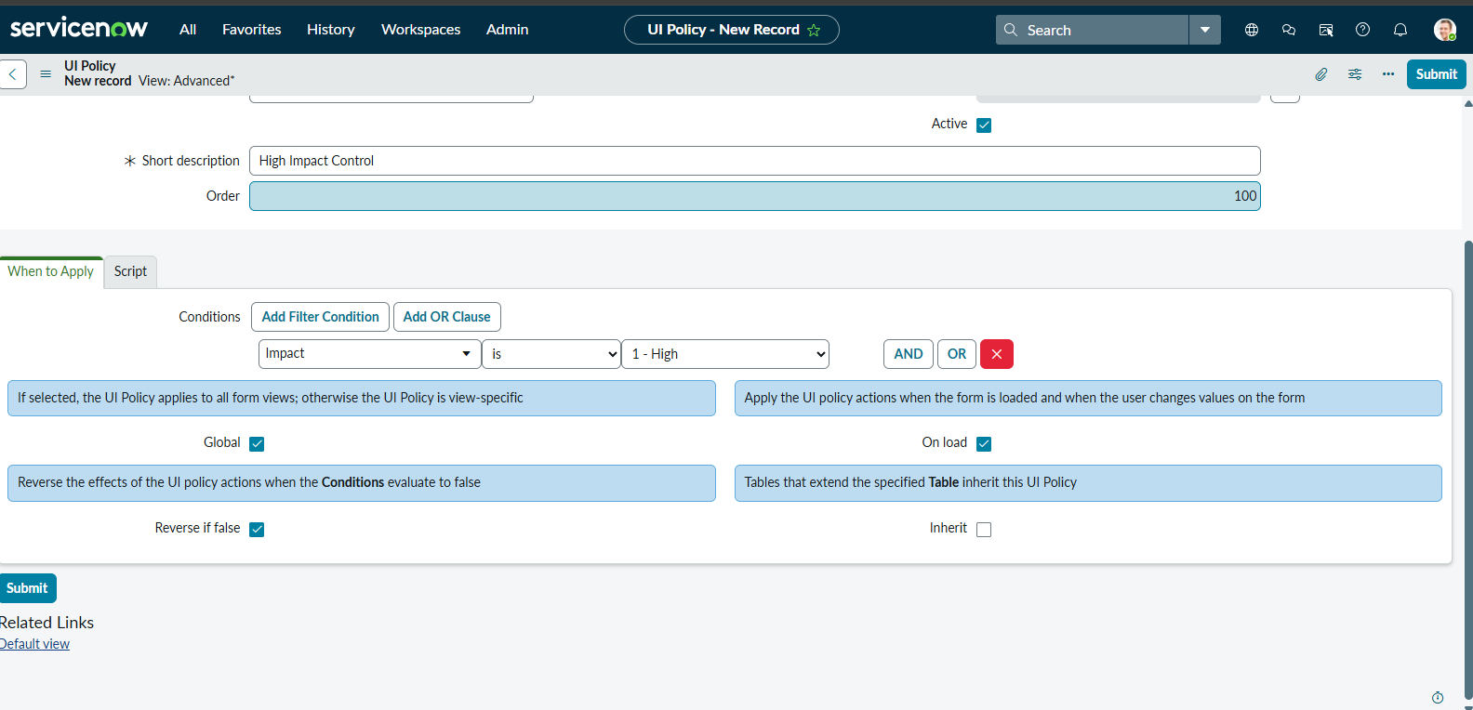

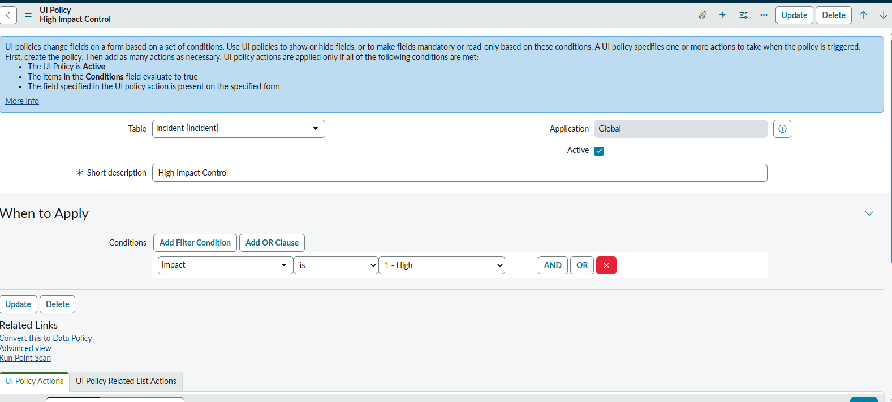

12. Conclusion
The Project Planning Phase provides a structured approach for completing the Implement Client Script & UI Policy (Incident) project. It identifies the project scope, activities, schedule, required resources, task dependencies, risks, testing activities, and expected deliverables.
The work is organized into manageable stages, beginning with preparation and configuration, continuing through Client Script development, and ending with testing and documentation. This sequence helps ensure that each component is implemented and verified before the project is considered complete.
The planning phase also prepares for possible implementation difficulties by identifying risks such as insufficient access, incorrect field values, script errors, and incomplete testing. By tracking tasks and comparing actual results with the requirements, the project can be monitored throughout development.
Overall, this phase serves as a roadmap for implementation. It helps organize the work, use available resources effectively, and provide a clear basis for verifying that the ServiceNow Incident controls meet the project's stated objectives.

